Report – EV Range Prediction AI System

Project Title :
EV Range Predictor – AI Model for Forecasting Electric Vehicle Driving Range
Objective :
To build a machine learning system that predicts the driving range (km) of an Electric Vehicle (EV) based on its technical specifications such as battery capacity, torque, acceleration, charging power, and vehicle dimensions.
This model will later be integrated into a chatbot that allows users to ask:
- “What is the predicted range of this EV?”
- “If battery capacity is 75 kWh, what range can I expect?”
- “How does torque affect range?”

Tools & Technologies Used :
1. Python
Used for data cleaning, preprocessing, and building the ML model.
2. Google Colab / Jupyter Notebook
Used to run the ML training code and generate results.
3. Pandas / NumPy / Matplotlib
For dataset handling, analytics and visualization.
4. Scikit-Learn (sklearn)
Used for building regression models such as:
- Linear Regression
- Random Forest Regressor
- Gradient Boosting Regressor
5. GitHub
Used to store the complete project files (dataset, ML code, model, Streamlit app).
6. Streamlit
Used to later create a web UI or chatbot interface.
Dataset Used :
Kaggle Dataset – Electric Car Performance and Battery Dataset
You downloaded the dataset and created:
✔ electric_vehicle_raw_data.csv
✔ electric_vehicle_cleaned_data.csv (after removing nulls)

Selected Problem Statement (PS) :
Predict the driving range (in km) of an Electric Vehicle using Machine Learning.

Dependent Variable (Y):
range_km

Independent Variables (X):
top_speed_kmh ,
battery_capacity_kWh ,
number_of_cells ,
torque_nm ,
efficiency_wh_per_km ,
acceleration_0_100_s,
fast_charging_power_kw_dc,
length_mm ,
width_mm ,
height_mm

Week 1 - Data Cleaning :
✔ Step 1 — Collected dataset from Kaggle
Using Google Colab & KaggleHub.
✔ Step 2 — Loaded dataset into Colab
Using Pandas.
✔ Step 3 — Performed data cleaning
- Removed null values
- Removed string-based columns not required for ML
- Saved cleaned dataset as CSV
✔ Step 4 — Identified independent & dependent variables
These features will be used for ML model training in Week 2.

Sample Data (for reference) :

Feature | Description
battery_capacity_kWh | Battery size of EV
torque_nm | Motor torque
efficiency_wh_per_km | Energy consumption
acceleration_0_100_s | 0–100 speed in seconds
fast_charging_power_kw_dc | DC charging power
length_mm | Vehicle length
range_km | Target variable

Week 2 – Visualization , EDA & Model Training :
Predicting EV Range Using Your Cleaned Dataset

1️⃣ Import Libraries
import pandas as pd
import numpy as np
import matplotlib.pyplot as plt
import seaborn as sns

2️⃣ Load Your Cleaned Dataset
data = pd.read_csv("electric_vehicle_cleaned_data.csv")
data.head()

3️⃣ Select Only Required Columns
data = data[[
'range_km',
'top_speed_kmh',
'battery_capacity_kWh',
'number_of_cells',
'torque_nm',
'efficiency_wh_per_km',
'acceleration_0_100_s',
'fast_charging_power_kw_dc',
'length_mm',
'width_mm',
'height_mm'
]]

4️⃣ Define Independent (X) and Dependent (y) Variables
x = data.drop('range_km', axis = 1)
y = data['range_km']

5️⃣ Train–Test Split
from sklearn.model_selection import train_test_split

x_train, x_test, y_train, y_test = train_test_split(
x, y, test_size = 0.2, random_state = 42 )

6️⃣ Handle Missing Values (Safe Imputation)
x_train_imputed = x_train.fillna(x_train.mean())
x_test_imputed = x_test.fillna(x_train.mean())

7️⃣ Train Linear Regression Model
from sklearn.linear_model import LinearRegression

model = LinearRegression()
model.fit(x_train_imputed, y_train)

8️⃣ Make Predictions
y_pred = model.predict(x_test_imputed)

9️⃣ Model Evaluation — MSE
from sklearn.metrics import mean_squared_error

mse = mean_squared_error(y_test, y_pred)

🔟 Model Evaluation — R² Score
from sklearn.metrics import r2_score

r2 = r2_score(y_test, y_pred)

Week 3 – Streamlit Application (or) Chatbot
3.1 Created Input Form (Streamlit UI):
A Streamlit user interface was built to allow users to enter the following EV features:
- Top Speed (km/h)
- Battery Capacity (kWh)
- Number of Cells
- Torque (Nm)
- Efficiency (Wh/km)
- Acceleration (0–100 sec)
- Fast Charging Power (kW DC)
- Length (mm)
- Width (mm)
- Height (mm)
These were the same features used during model training.

3.2 Loaded the Trained Model:
The trained LinearRegression() model was saved using:
joblib.dump(model, "ev_range_predictor.joblib")
Then reloaded in Streamlit using:
model = joblib.load("models/ev_range_predictor.joblib")
metadata = json.load(open("models/metadata.json"))
This makes the app instantly predict range based on user inputs.

3.3 Displayed Predicted EV Range :
After the user fills in the input form, the app calculates and displays:
Predicted Range: XXX km

3.4 Added Explanation for Prediction
A small explanation section was added to show:
- Important features
- How each feature influences EV range
- Example: “Higher battery capacity usually increases range.”
- Example: “Lower efficiency (Wh/km) results in better range.”
This improves transparency and helps users understand the result.

3.5 Technologies Used :
Component | Technology
Programming | Python
ML Library | Scikit-learn
Data Processing | Pandas, NumPy
Visualization | Matplotlib, Seaborn
Model Storage | Joblib
UI Framework | Streamlit
Deployment | Streamlit Cloud

3.6 Output Screens (Describe or Attach) :
The final Streamlit app includes:
- Clean input form with sliders and text fields
- Instant prediction output
- Explanation block
- Professional UI with modern layout

Expected Output (End of Project):
A complete AI-based range prediction system including:
✔ ML Model
Predict EV range using vehicle features.
✔ Streamlit Application
User enters EV details → App predicts range.
✔ Chatbot (Optional Advanced Feature)
→ Users ask: battery_capacity_kWh:75 torque_nm:450 efficiency_wh_per_km:180 number_of_cells:96 length_mm:4680 width_mm:1840 height_mm:1440 top_speed_kmh:180 acceleration_0_100_s:6.5 fast_charging_power_kw_dc:150
→ Bot returns model prediction answer.

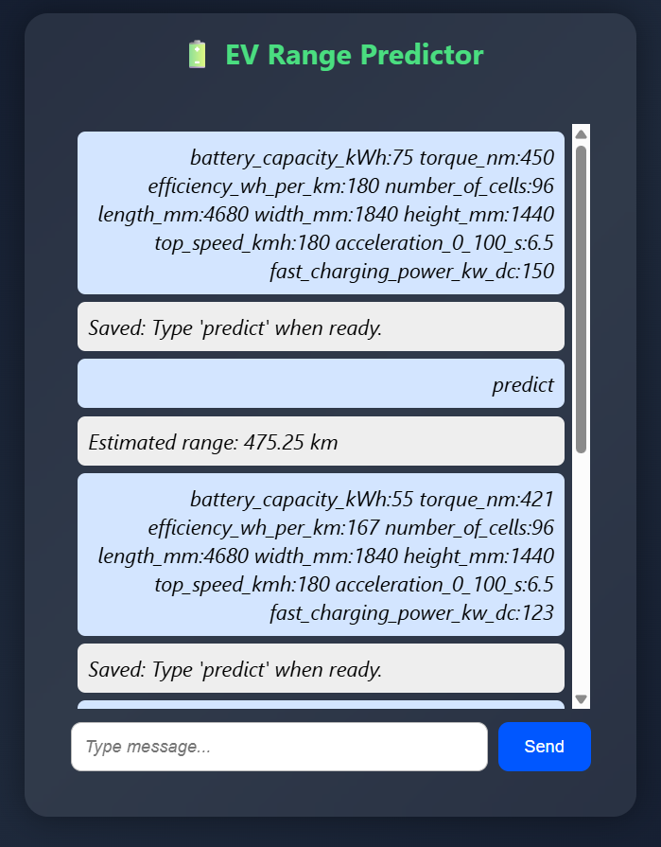
Streamlit App Output

